THE WORSHIP OF GOD

The Gathering

*Indicates congregation may stand.
Prelude

Welcome and Announcement Please sign & pass the fellowship pad.

Introit
Please use this contemplative time to prepare yourself to encounter God in this time and place.

“All scripture is breathed out by God and profitable for teaching, for reproof, for correction and for training in righteousness.”
II Timothy 3:16

*God Calls Us to Worship

We have gathered in God’s holy presence, the One who etches grace on our hearts.
This is the place where God will transform us into disciples.
We glorify our God, who yearns for justice, not just for a favored few, but for the least of our world.
This is the place where God will write compassion on our souls.
We give thanks to God for unceasing grace; we remember God’s persistence in saving us.
This is the place where God will breathe the Word into our lives.

*Hymn of Praise “He’s Got the Whole World in His Hands” No. 344

*Call to Reconciliation

Seeking to follow Jesus, we often wander down the wrong roads. Impatient with God’s schedule, we rush off to do things our way. Let us confess our foolishness, that we might receive God’s hope for our lives.

*Unison Prayer for Forgiveness

Author of Life, Your words are given to us, so we might be reformed, but we are more intent on changing others. Your words are offered to us so we might be transformed, but we are focused on conforming to our culture. Your words are spoken to lead us into new life, but we hold our old ways tight to our chests.
Forgive us, God of Wonder, do not remember our sins, but continue to touch us with Your steadfast mercy. Show us how to be persistent in living out our faith, even as You were so tenacious in offering us Your grace and life in Jesus Christ, our Lord and Savior, through whom we pray, “Our Father, who art in heaven, hallowed be thy name, Thy kingdom come, Thy will be done, on earth as it is in heaven. Give us this day our daily bread. And forgive us our debts, as we forgive our debtors. And lead us not into temptation but deliver us from evil. For Thine is the kingdom, and the power, and the glory forever, Amen.”

Assurance of Pardon

Prayer of Dedication

*Gloria Patri
Glory be to the Father, and to the Son, and to the Holy Ghost; As it was in the beginning, is now and ever shall be, world without end. Amen. Amen

*The Peace

The peace of God be with you.
And also with you.

*Children’s Message
Please come forward during Passing of the Peace

THE WORD

Old Testament Reading Isaiah 26:3
New Testament Reading II Peter 1:5-9
Expounding God’s Word “As followers of Christ, we never give up”

The Response

*Hymn of Response “Take My Life” No. 379

*Bringing Our Gifts to God

*Doxology
Praise God, from whom all blessings flow; Praise *God all creatures here below;
Praise *God above, ye heavenly host; Praise Father, Son, and Holy Ghost. Amen.
(*or “Him”)

*Closing Hymn “Onward, Christian Soldiers” No. 479

*Benediction

*Choral Closing “Ye Servants of God” No. 17

YE SERVANTS OF GOD YOUR MASTER PROCLAIM
AND PUBLISH ABROAD HIS WONDERFUL NAME;
THE NAMES ALL VICTORIOUS OF JESUS EXTOL;
HIS KINGDOM IS GLORIOUS, HE RULES OVER ALL.

Postlude
participating in the Service Today
Minister Rev. Daniel Winkowistch
Liturgist Molly Jo Anderson
Organist Daryl Gommels
Worship Coordinator Kelly Claude
Sound Operator Lowell Swalve
A/V Operator Lori Donovan/Beth Carrico
Chairlift Operator Larry Harsin
Radio Broadcast Sponsored by: Tanya Clabaugh in honor of her brother Randy

First Presbyterian Church
723 First Avenue South
Estherville, IA 51334
Phone: 712-362-4772 | E-mail: 1.church@mchsi.com
esthervillepresbyterian.com

Ordained Leaders and Elected Officers
Session –Kelly Claude, Molly Jo Anderson, Aaron Ruschy, Lori Donovan, Paul Moffitt, Walt Jensen, Kevin Sander, and Craig White.
Deacons –Janet Anderson, Cheryl Klingbeil, Evy Strenge, Georgia Whitehouse, Lavonne Ruschy, Kevin Strenge, John Klingbeil,
Mary Clabaugh and Pat Johnson.
PROGRAM STAFF - Darla Lundgren, Administrative Assistant, Daryl Gommels, Custodian

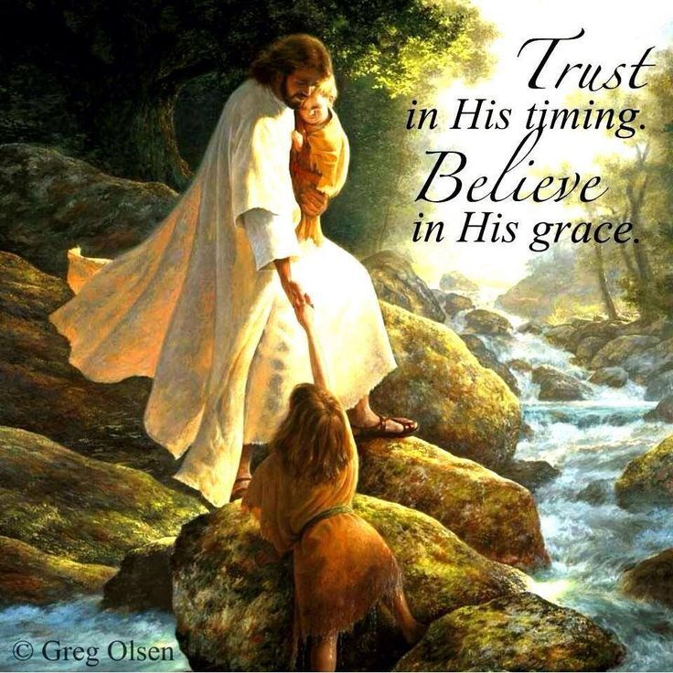

“As followers of Christ, we never give up”

First Presbyterian Church
19th Sunday after Pentecost
16 October 2022 - 10:30 A.M.

