We Gather to Worship God

*Indicates congregation may stand.
Prelude
Welcome and Announcement Please sign & pass the fellowship pad.

Introit
Please use this contemplative time to prepare yourself to encounter God in this time and place.

“Jesus said to him, “I am the way, and the truth, and the life. No one comes to the Father except through me.” John 14:6

Call to Worship
We are God's household, crafted by the Architect of creation:
Our hearts a shelter for the outcast; our hands open to the stranger.
We are God's people, created in the divine image:
To tell others of God's love, to offer mercy as freely as we have received it.
We are God's children, called to give of ourselves:
Chosen to serve the lost and lonely, gifted to minister to a hurting world.
*Hymn of Praise “Open My Eyes That I May See” 381

Call To Reconciliation
Considered to rough for their smooth plans, the builders cast out the Stone they needed. But God builds salvation on the One who is the foundation of all hope. Let us confess our sins to God and one another, trusting we will not be put to shame as we join together in prayer,
*Unison Prayer of Forgiveness
Hear the brokenness of our lives, Precious God. We cover our ears so we cannot hear the cries of those in need, or You urging us to respond. We rush together to defend the issues that matter to us, but quickly disperse when You would call us to be Your holy people. We shout as loud as we can to cheer on our sports teams but can manage only whispers when it comes to sharing the good news.
Forgive us, our Eternal Guide, and do not hold our sins against us. We lay the garments of our foolishness at Your feet, so You might clothe us in grace and hope. We would feed on the spiritual food which flows from Your heart so we might be strong enough to follow Jesus as he leads us in the Way, the Truth, and the Life, beginning with our prayers to You, “Our Father… Amen.”
*Assurance of Pardon

*gloria patri
Glory be to the Father, and to the Son, and to the Holy Ghost; As it was in
the beginning, is now and ever shall be, world without end. Amen. Amen

*The Peace
The peace of God be with you.
And also with you.
Greet one another as you pass the peace of Christ.

Children’s Message
Please come forward during Passing of the Peace

THE WORD

Old Testament Reading Psalm 31:1-10
New Testament Reading John 14:1-14

Expounding God’s Word “There Is Only One Way”

The Response

*Hymn of Response “Jesus, the Very Thought of Thee” 79

Bringing Our Gifts to God

*Doxology
Praise God, from whom all blessings flow; Praise *Him all creatures here below;
Praise *God above, ye heavenly host; Praise Father, Son, and Holy Ghost. Amen.

*Prayer of Dedication
Accept the gifts of our hands and the thankfulness of our hearts. Hearts and hands and voices, all lifted in praise to You, God of our life! Amen.

*Closing Hymn “Thine Is the Glory” 227

*Benediction

*Postlude

Closing Chorus:
Ev'ry morning is Easter morning from now on!
Ev'ry day's resurrection day, the past is over and gone!
Ev'ry morning is Easter morning, Ev'ry morning is Easter morning,
Ev'ry morning is Easter morning, From - now - on!

Participating in the Service Today
Minister Pastor Dave Ullom
Organist Daryl Gommels
Radio Broadcast Sponsored by Jan Greig in memory of loved ones

First Presbyterian Church
723 First Avenue South
Estherville, IA 51334
Phone: 712-362-4772 | E-mail: 1.church@mchsi.com
esthervillepresbyterian.com
Ordained Leaders and Elected Officers
Session –Molly Jo Anderson, Paul Moffitt, Walt Jensen, Kevin Sander, Craig White, Lori Donovan, Tara Anderson and Margaret White.
Deacons –Janet Anderson, Cheryl Klingbeil, Evy Strenge, Georgia Whitehouse, John Klingbeil, Mary Clabaugh, Pat Johnson, Jan Greig and Dina Poyzer.
PROGRAM STAFF - Darla Lundgren, Administrative Assistant and Daryl Gommels, Custodian

Please connect to WiFi @ FirstPres-Guest; password is Jesus123

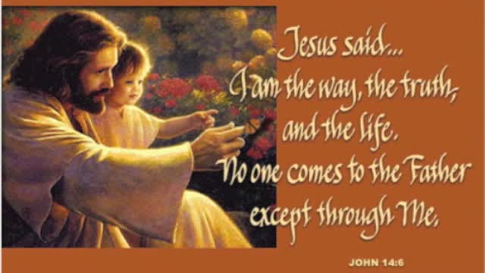

Following Jesus is the only way we can find God in our lives

First Presbyterian Church
Fifth Sunday of Easter
May 7, 2023 -10:30 A.M.

