We Gather to Worship God

*Indicates congregation may stand.
Prelude
Welcome and Announcement Please sign & pass the fellowship pad.

Introit
Please use this contemplative time to prepare yourself to encounter God in this time and place.

“The Lord is my strength and my song; he has become my salvation.” Psalm 118:14.

Call to Worship
This is the day!
Steadfast love celebrates in cemeteries; peace spreads like wildfire through creation.
This is the day God has smashed the cornerstone of death's power;
Dispelled the shadows of grief with the joy of resurrection.
This is the day God has made!
All people are the same through gracious love, with new words to speak to a weary world.
This is the day of resurrection!
Christ is risen! Christ is risen indeed!
*Hymn of Praise “Christ the Lord Is Risen Today” 217

Call To Reconciliation
Sin clings to us as if we were its most precious possession, but just as death's grip on Jesus was broken on that first morning, so God will release us from the grasp of sin. Let us confess to the One who offers us resurrection life, as we pray together, saying,
*Unison Prayer of Forgiveness
God of our lives, on this first day of the week, we confess. We wander in the shadows of temptation, ignoring the Light You offer to us. We are asked to proclaim the good news of life anew but continue to speak the old words of despair. You would anoint us with the Holy Spirit, but we put up the umbrellas of fear to keep even the holy showers of blessing from touching us.
You hear our prayers, God of Easter joy, and You answer us with forgiveness! On this morning, You give us new life. On this day, we are transformed from mourners into witnesses of the resurrection. In the days to come, we will run to share the good news that Jesus, our Lord and Savior, is alive and in our midst, and we will continue to pray to You, “Our Father… Amen.”
*Assurance of Pardon

*gloria patri
Glory be to the Father, and to the Son, and to the Holy Ghost; As it was in
the beginning, is now and ever shall be, world without end. Amen. Amen

*The Peace
The peace of God be with you.
And also with you.
Greet one another as you pass the peace of Christ.

Children’s Message
Please come forward during Passing of the Peace

Special Music “Resurrection Medley” Daryl Gommels

Apostle’s Creed
THE WORD

Old Testament Reading Psalm 118:14-24
New Testament Reading Matthew 28:1-15
Expounding God’s Word “Death Has Lost Its Power Over Us”

The Response

*Hymn of Response “Because He Lives” 213

Bringing Our Gifts to God

*Doxology
Praise God, from whom all blessings flow; Praise *Him all creatures here below;
Praise *God above, ye heavenly host; Praise Father, Son, and Holy Ghost. Amen.

*Prayer of Dedication
Giver of all good things, let Your grace flow through us; a generous stream, unstoppable, refreshing, abundant. We release these gifts into Your river of love, flowing out to all the world. Amen

*Closing Hymn “Christ Arose” 216
*Benediction
*Postlude
Participating in the Service Today
Minister Pastor Dave Ullom
Organist Daryl Gommels
Radio Broadcast Sponsored by Tanya Clabaugh in memory of her dad

First Presbyterian Church
723 First Avenue South
Estherville, IA 51334
Phone: 712-362-4772 | E-mail: 1.church@mchsi.com
esthervillepresbyterian.com
Ordained Leaders and Elected Officers
Session –Molly Jo Anderson, Paul Moffitt, Walt Jensen, Kevin Sander, Craig White, Lori Donovan, Tara Anderson and Margaret White.
Deacons –Janet Anderson, Cheryl Klingbeil, Evy Strenge, Georgia Whitehouse, John Klingbeil, Mary Clabaugh, Pat Johnson, Jan Greig and Dina Poyzer.
PROGRAM STAFF - Darla Lundgren, Administrative Assistant and Daryl Gommels, Custodian

Please connect to WiFi @ FirstPres-Guest; password is Jesus123

Why should you join in worship each week
“Let us consider how to stir up one another to love and good works, not neglecting to meet together, as is the habit of some, but encouraging one another, and all the more as you see the Day drawing near” (Heb. 10:24–25).
What are some reasons you should regularly participate in public and corporate worship?
Reason number: 10 You need the encouragement that comes from the assembling of the saints (Heb. 10:24–25). The more evil the days become, the more you need this encouragement.

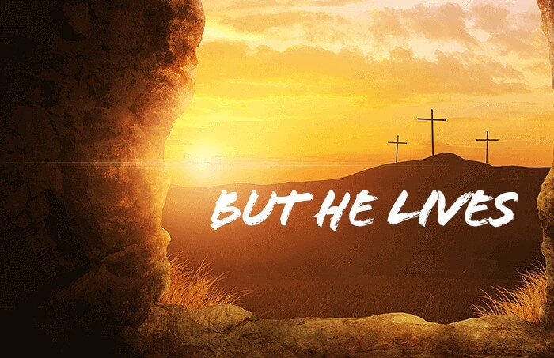

The tomb is empty because Christ is risen!

First Presbyterian Church
Easter Sunday
April 9, 2023 -10:30 A.M.

