This Week at


Please be in prayer for…
Onalee Robinson
Macklin Nikkel baby born to cousin of Larry Harsin
Jolene Greving
Josh Ullom
Alex White
Arlis Fox
Alice Jensen
Elaine Jensen
Steele McLaren
Paul Moffitt
Diane Swalve

How can we pray for you?
Whether you have a heart filled with worry or joy, we want to pray for you! To submit a prayer request, please fill out the prayer request form found in this trifold and place it in the offering plate during worship. If you prefer, you may also submit prayer
362-4772 requests via the church office.
info@esthervillepresbyterian.com
PO Box 476, Estherville, IA 51334
*********************************************
If any of these congregants are well or would like off this list, please leave a notation for me, in secretary’s office. We continue to pray for all regardless of health or injury.
Darla L, Sec.

*********************************************
Please remember to turn the sound off on your
phone during worship

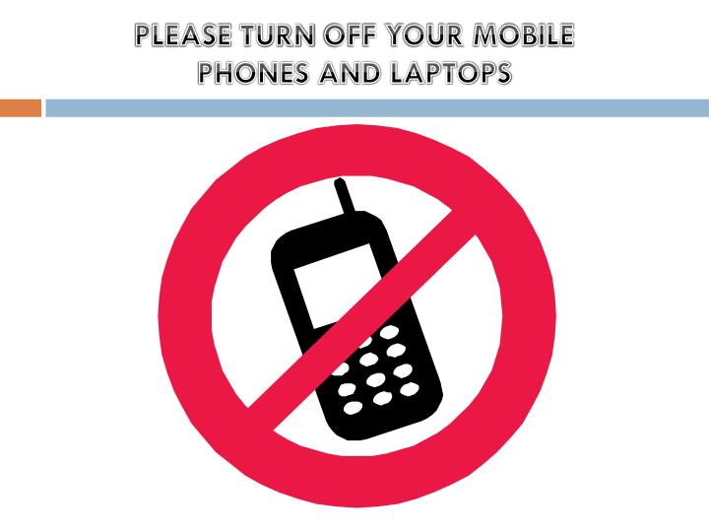
First Presbyterian Church
Today ~ November 20th ²⁰²²
Worship…………………………………………………….10:30AM
.
Community Christmas Project
is accepting donations for warm clothing, all sizes for men, women and children, toys, bedding, towels, and books. NEW items only please. There are flyers on the long table in the back of the sanctuary. The deadline for giving is November 27th and can be dropped off at the Duhigg Center gymnasium
Please give generously

God is Good ALL the time

Tuesday November 22nd ²⁰²²
Office Hour…………………………………9:00AM-12:00PM

Wednesday November 23rd ²⁰²²
Office hours…………………………………9:00AM-12:00PM

Thursday November 24th ²⁰²²
Office Hours 9:00AM-12:00PM

FRIDAY November 25^{th 2022}
Office hours………………………………...9:00AM-12:00PM

sunday November 27^{th 2022}
Adult Sunday School……………………………………… .9:30am
Worship 10:30AM

Office Hours
Tuesday- 9:00AM-12:00PM
Wednesday- 9:00AM-12:00PM
Thursday- 9:00AM-12:00PM
Friday- 9:00AM-12:00PM

First Presbyterian Church

Dear Congregation,
Our church is way behind in Per Capita giving and Radio Broadcast donations. These are important financial giving’s that keep us functioning throughout the year.
We thank you for all you do to keep Estherville First Presbyterian going.
May God Bless You and we appreciate our entire congregation.

PER CAPITA for 2022 is:
$42.48

General Fund: 11-13-22…. $1851.50
info@esthervillepresbyterian.com

712-362-4772

Prayer Request
We would be glad to join with you in prayer. Please write your request here and place it in the offering plate. Please choose as many as apply.
I would like my request to:
- go to the pastor.
- go to the prayer chain.
- be listed in the Prayers of the People.
- be listed in the bulletin.
- be listed in next month’s newsletter.
____________________________________________________________________________________________________________________________________________________________________________________________________________________________
Requested by:_________________________________
Date:_______________________________________


Vacation Bible School Opportunity:
Estherville United Methodist Church
Monday, July 31st – Wed. August 2nd
5:30-8:00pm (Supper served at 5:30pm)
For ages 3 (not in diapers) to 6th Grade


Holy Moly Book Club
Meets the 2nd Thursday of the month
at 11:00AM
Location TBD


Birthdays
November 24- Lynda Hart
Anniversaries
November 24- Steve & Jean Rose
November 25- Neal & Bobbi Jo Ruschy
~~~~~~~~~~~~~~~~~~~~~~~~~~~~~~~~~
Buildings and Grounds Committee Meeting
December 4th at 11:30am

Worship Committee Meeting
December 5th at 5:30pm

Generosity Committee Meeting
TBD

A Community Thanksgiving Service organized through the Estherville Area Ministerial Association will be held Sunday, Nov. 20, at Trinity Lutheran Church in Estherville. An ‘Apple Pie Fellowship’ will be held at 3 p.m. followed by the worship service at 4 p.m. The offering will go toward local food pantries. We hope you can come fellowship and worship with us.



November Project ELC Backpack Program
Needs
Non-perishable food items individually wrapped
Snack items such as:
Granola Bars/Crackers
Fruit snacks
Animal Crackers
Beef Jerky Sticks
Personal Hygiene items such as:
Shampoo/Conditioner
Soap
Deodorant
Toothpaste/Toothbrushes
Hairbrush/Combs
Socks
Hats, Scarves, Gloves/Mittens all sizes

************************
Second Sunday Snacks
- December 11th - ½ Session
- January 8th – Generosity
- February 12th – ½ Session
- March 12th – 1/3 Deacons

Free Wi Fi available

FirstPres-guest

Password: Jesus123

Christmas Cookie Walk
Saturday, December 10th, 2022
Duhigg Center- South Door
902 E. Central Ave, Estherville
9:00AM-2PM
Let St. Patrick’s & St. Mary’s
Catholic Church do your Christmas baking for you!
Boxes are provided for your selections-$7.00 per pound

