This Week at


Please be in prayer for…
Onalee Robinson
Macklin Nikkel baby born to cousin of Larry Harsin
Jolene Greving
Josh Ullom
Alex White
Arlis Fox
Alice Jensen
Elaine Jensen
Steele McLaren
Paul Moffitt
Diane Swalve

How can we pray for you?
Whether you have a heart filled with worry or joy, we want to pray for you! To submit a prayer request, please fill out the prayer request form found in this trifold and place it in the offering plate during worship. If you prefer, you may also submit prayer
362-4772 requests via the church office.
info@esthervillepresbyterian.com
PO Box 476, Estherville, IA 51334
*********************************************
If any of these congregants are well or would like off this list, please leave a notation for me, in secretary’s office. We continue to pray for all regardless of health or injury.
Darla L, Sec.

*********************************************
Please remember to turn the sound off on your
phone during worship

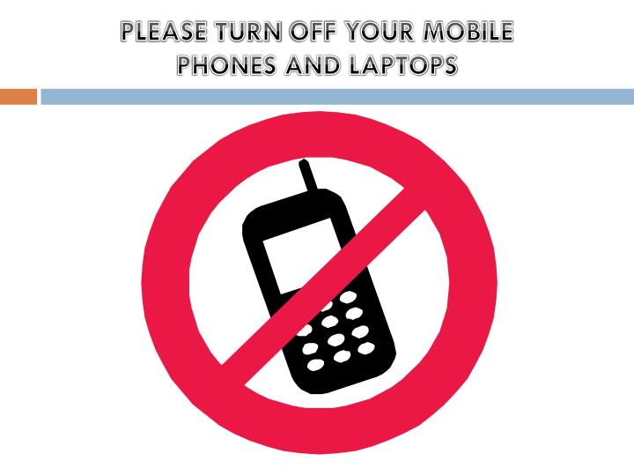
First Presbyterian Church
Today ~ November 13th ²⁰²²
Worship…………………………………………………….10:30AM

Tuesday November 15th ²⁰²²
Office Hour…………………………………9:00AM-12:00PM

Wednesday November 16th ²⁰²²
Office hours…………………………………9:00AM-12:00PM

Thursday November 17th ²⁰²²
Office Hours 9:00AM-12:00PM

FRIDAY November 18^{th 2022}
Office hours………………………………...9:00AM-12:00PM

sunday November 20^{th 2022}
Adult Sunday School……………………………………… .9:30am
Worship 10:30AM

Office Hours
Tuesday- 9:00AM-12:00PM
Wednesday- 9:00AM-12:00PM
Thursday- 9:00AM-12:00PM
Friday- 9:00AM-12:00PM

First Presbyterian Church

Dear Congregation,
Our church is way behind in Per Capita giving and Radio Broadcast donations. These are important financial giving’s that keep us functioning throughout the year.
We thank you for all you do to keep Estherville First Presbyterian going.
May God Bless You and we appreciate our entire congregation.

PER CAPITA for 2022 is:
$42.48

General Fund: 11-06-22…. $1696.05
info@esthervillepresbyterian.com

712-362-4772
.
Adult Sunday School each Sunday @ 9:30am

Buildings & Grounds
Sunday, 11:30am, 12-04-22

Worship Committee
Monday, 5:30pm, 12-05-22

Generosity Committee
TBD
-----------------------------------------------------------------------------
Community Christmas Project is accepting donations for warm clothing, all sizes for men, women and children, toys, bedding, towels, and books. NEW items only please.
There are flyers on the long table in the back of the sanctuary. The deadline for giving is November 27th and can be dropped off at the Duhigg Center gymnasium
Please give generously

Prayer Request
We would be glad to join with you in prayer. Please write your request here and place it in the offering plate. Please choose as many as apply.
I would like my request to:
- go to the pastor.
- go to the prayer chain.
- be listed in the Prayers of the People.
- be listed in the bulletin.
- be listed in next month’s newsletter.
____________________________________________________________________________________________________________________________________________________________________________________________________________________________
Requested by:_________________________________
Date:_______________________________________


Vacation Bible School Opportunity:
Estherville United Methodist Church
Monday, July 31st – Wed. August 2nd
5:30-8:00pm (Supper served at 5:30pm)
For ages 3 (not in diapers) to 6th Grade


Holy Moly Book Club
Meets the 2nd Thursday of the month
at 11:00AM
Location TBD


Birthdays
Nov 15- Olivia Kollasch
Nov 15- Brad Hermanson
Nov 15- Georgia Whitehouse
Nov 16- Mary Clabaugh
Nov 17- Tanya Clabaugh
Nov 18- James Rosendahl
Nov 19- Cheryl Baddeley

Anniversaries
None
~~~~~~~~~~~~~~~~~~~~~~~~~~~~~~~~~

God is Good
All the Time

Our sympathies go out to the family of Mary Anita Juhl as she passed away Monday, November 7th. Her funeral services were here at 10:30AM on Saturday, November 12th 



November Project ELC Backpack Program
Needs
Non-perishable food items individually wrapped
Snack items such as:
Granola Bars/Crackers
Fruit snacks
Animal Crackers
Beef Jerky Sticks
Personal Hygiene items such as:
Shampoo/Conditioner
Soap
Deodorant
Toothpaste/Toothbrushes
Hairbrush/Combs
Socks
Hats, Scarves, Gloves/Mittens all sizes

************************

Second Sunday Snacks
- November 13th – 1/3 Deacons
- December 11th - ½ Session

Free Wi Fi available

FirstPres-guest

Password: Jesus123

