THE WORSHIP OF GOD

The Gathering

*Indicates congregation may stand.
Prelude
Welcome and Announcement Please sign & pass the fellowship pad.

Introit
Please use this contemplative time to prepare yourself to encounter God in this time and place.

“Seek the welfare of the city where I have sent you into exile, and pray to the LORD on its behalf, for in its welfare you will find your welfare.”
Jeremiah 29:7.

Call to Worship
This day we will give thanks to God.
This day we will trust in the One who has saved us, who strengthens us.
This day we dance to the fountain of life, drinking deeply of salvation's goodness.
This day! This day we praise our God for every blessing; telling everyone of God's amazing grace in our lives and in our world.
This day we sing God's praises; testifying to all creation of our God.
This day our songs are filled with joy, for God is with us, this day and in all the days to come!

Call To Reconciliation
God does not take our sins and stick them up on a shelf, in order to remember them - God forgets them! God does not hold them against us, but forgives us! Join me as we pray to the One who delights in us, as we say,
*Unison Prayer of Forgiveness
Strengthening God, we confess our weakness. We do not exercise our faith as we should. We whimper our petty complaints about our friends and families, rather than shouting our hosannas to heaven for the gift of their lives.
You are our hope, Tender God, so forgive us. Create in us new hearts, and fill us with new energy to serve our sisters and brothers, bringing them to the deep wells of salvation, where they can fill their parched souls, even as we have been led to them by Jesus Christ, our Lord and Savior and taught us to pray, “Our Father… Amen.”

*Hymn of Praise “What a Friend We Have in Jesus” No.435

*Assurance of Pardon
Rather than remaining white hot, God’s anger melts into streams of living water, washing us clean of our sins and refreshing our spirits with hope and joy. This day! This day we give thanks to the God who is our strength and our salvation. Praise God! Amen.

*gloria patri
Glory be to the Father, and to the Son, and to the Holy Ghost; As it was in
the beginning, is now and ever shall be, world without end. Amen. Amen

*The Peace
The peace of God be with you.
And also with you.
Greet one another as you pass the peace of Christ.

Children’s Message
Please come forward during Passing of the Peace

THE WORD

Old Testament Reading Jeremiah 29:1-7
New Testament Reading Luke 17:11-19

Expounding God’s Word “Healing the Spirit”

The Response

*Hymn of Response “Tell Me the Old, Old Story” No. 424

The Scots Confession of Faith

Bringing Our Gifts to God

*Doxology
Praise God, from whom all blessings flow; Praise *Him all creatures here below;
Praise *God above, ye heavenly host; Praise Father, Son, and Holy Ghost. Amen.

*Prayer of Dedication
Over and over Your grace sustains us, over and over Your love provides for us, over
and over Your arm steadies us. We give You these gifts, with gratitude and joy, thankful that you are God over all. Amen.

*Closing Hymn “A Shelter in the Time of Storm” No. 353

*Benediction

*Postlude

Participating in the Service Today
Minister Rev. Dr. Dave Ullom
Organist Daryl Gommels
Worship Coordinator Melissa Patrick
Sound Operator Lowell Swalve
Liturgist Evy Strenge
A/V Operator Lori Donovan
Chairlift Operator Larry Harsin
Radio Broadcast Sponsored by Lavonne Ruschy in memory of loved ones

First Presbyterian Church
723 First Avenue South
Estherville, IA 51334
Phone: 712-362-4772 | E-mail: 1.church@mchsi.com
esthervillepresbyterian.com
Ordained Leaders and Elected Officers
Session –Kelly Claude, Molly Jo Anderson, Aaron Ruschy, Lori Donovan, Paul Moffitt, Walt Jensen, Kevin Sander, and Craig White.
Deacons –Janet Anderson, Cheryl Klingbeil, Evy Strenge, Georgia Whitehouse, Lavonne Ruschy, Kevin Strenge, John Klingbeil, Mary Clabaugh and Pat Johnson.
PROGRAM STAFF - Darla Lundgren, Administrative Assistant and Daryl Gommels, Custodian

Please connect to WiFi @ FirstPres-Guest; password is Jesus123

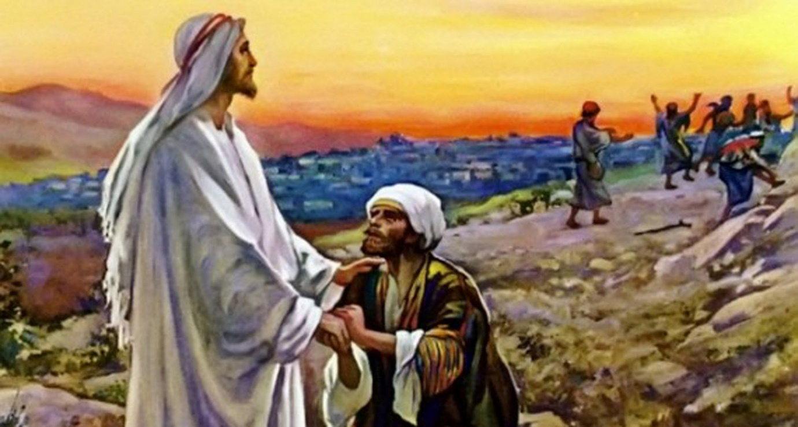

Jesus heals ten lepers and only one returns to give thanks.

First Presbyterian Church
reformation Sunday
25th Sunday after Pentecost
13 November, 2022-10:30 A.M.

