This Week at


Please be in prayer for…
Onalee Robinson
Macklin Nikkel baby born to cousin of Larry Harsin
Jolene Greving
Josh Ullom
Alex White
Arlis Fox
Alice Jensen
Elaine Jensen
Steele McLaren
Paul Moffitt
Jonathan Donovan
Diane Swalve

How can we pray for you?
Whether you have a heart filled with worry or joy, we want to pray for you! To submit a prayer request, please fill out the prayer request form found in this trifold and place it in the offering plate during worship. If you prefer, you may also submit prayer
362-4772 requests via the church office.
info@esthervillepresbyterian.com
PO Box 476, Estherville, IA 51334

*********************************************
If any of these congregants are well or would like off this list, please leave a notation for me, in secretary’s office. We continue to pray for all regardless of health or injury.
Darla L, Sec.

Please remember to turn the sound off on your
phone during worship


First Presbyterian Church
Today ~ October 30th ²⁰²²
Worship…………………………………………………….10:30AM
.
Adult Sunday School each Sunday @ 9:30am

Buildings & Grounds
Sunday, 11:30am, 11-06-22

Worship Committee
Monday, 5:30pm, 11-07-22

Generosity Committee
TBD

-----------------------------------------------------------------------------
FREE LUNCH MONDAY
Join Us The 3rd Monday of Every Month for a Free Lunch At
Wesley’s Kitchen
United Methodist church
From 11:00AM – 12:30 PM
102 South 8th Street,
Estherville
Good Food and Great Fellowship!

Tuesday November 1st ²⁰²²
Office Hour…………………………………9:00AM-12:00PM

Wednesday November 2nd ²⁰²²
Office hours…………………………………9:00AM-12:00PM

Thursday November 3rd ²⁰²²
Office Hours 9:00AM-12:00PM

FRIDAY November 4th 2022
Office hours………………………………...9:00AM-12:00PM

sunday October 30th ²⁰²²
Adult Sunday School……………………………………… .9:30am
Worship 10:30AM

Office Hours
Tuesday- 9:00AM-12:00PM
Wednesday- 9:00AM-12:00PM
Thursday- 9:00AM-12:00PM
Friday- 9:00AM-12:00PM

First Presbyterian Church
2022 Giving Needed: $131,000 = $43,666 through April, which is $10,916 per month or $2,519 per week to meet the Budget.

Dear Congregation,
Our church is way behind in Per Capita giving and Radio Broadcast donations. These are important financial giving’s that keep us functioning throughout the year.
We thank you for all you do to keep Estherville First Presbyterian going.
May God Bless You and we appreciate our entire congregation.

PER CAPITA for 2022 is:
$42.48

General Fund: 10-16-22…. $1565.07
info@esthervillepresbyterian.com

712-362-4772

Prayer Request
We would be glad to join with you in prayer. Please write your request here and place it in the offering plate. Please choose as many as apply.
I would like my request to:
- go to the pastor.
- go to the prayer chain.
- be listed in the Prayers of the People.
- be listed in the bulletin.
- be listed in next month’s newsletter.
____________________________________________________________________________________________________________________________________________________________________________________________________________________________
Requested by:_________________________________
Date:_______________________________________


Vacation Bible School Opportunity:
Estherville United Methodist Church
Monday, July 31st – Wed. August 2nd
5:30-8:00pm (Supper served at 5:30pm)
For ages 3 (not in diapers) to 6th Grade

Stewardship Kickoff Sunday, October 30^{th,} 2022 with meal following service in Basement.
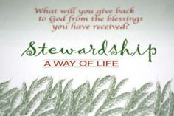

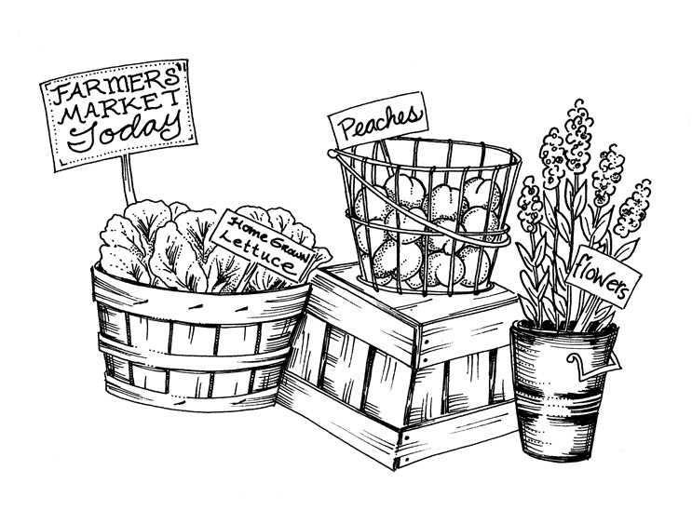

Downtown Market is now open
Thursdays 4:30pm – 6:30pm
Downtown Library Square



October Project ELC Backpack Program
Needs
Non-perishable food items individually wrapped
Snack items such as:
Granola Bars/Crackers
Fruit snacks
Animal Crackers
Beef Jerky Sticks
Personal Hygiene items such as:
Shampoo/Conditioner
Soap
Deodorant
Toothpaste/Toothbrushes
Hairbrush/Combs
Socks
Hats, Scarves, Gloves/Mittens all sizes

Second Sunday Snacks
- November 13th – 1/3 Deacons
- December 11th - ½ Session



Holy Moly Book Club
Meets the 2nd Thursday of the month
at 11:00AM
Location TBD



Birthdays
31- Emmanuel Sabwa

Anniversaries
None this week
~~~~~~~~~~~~~~~~~~~~~~~~~~~~~~~~~

Free Wi Fi available

FirstPres-guest

Password: Jesus123

