
THE WORSHIP OF GOD

The Gathering

*Indicates congregation may stand.
Prelude

Welcome and Announcement Please sign & pass the fellowship pad.

Introit
Please use this contemplative time to prepare yourself to encounter God in this time and place.

“Today salvation has come into this house.”

Luke 19:9.

*God Calls Us to Worship

We gather in awe,
Standing in the presence of the One who crafted the stars, the mountains, the seas.
We gather in faith,
Trusting that the One who has held little children holds our lives in the heart of God.
We gather in need,
Seeking the One who longs for justice to grace each and every person in creation.
*Hymn of Praise “Tis So Sweet to Trust in Jesus” No. 349

*Call to Reconciliation

How patient is God! We run around trying to do everything our way, and God just waits. We try to buy life and happiness, and God waits. We hurt others and walk away from those in need, and God waits. God waits, and upon hearing our heartfelt prayers and cries for help, God touches us with forgiveness and new life. Come, join me as we pray to the One who waits to hear - from us!

*Unison Prayer for Forgiveness

Patient God, we find it difficult to see You in our lives, which are surrounded by so
many seductions. Justice has a hard time surviving when there is so much persecution
and affliction towards the little ones of the world. Our world; our country; even our
homes, are filled with strife and contention
We cry for help, Listening God; forgive us! As we wait for Your grace to fill our lives,
may we open our hearts to Your hope and healing, always giving thanks for Jesus
Christ, our Lord and Savior, who taught us to pray, “Our Father… Amen.”

*Assurance of Pardon

*Prayer of Dedication

*Gloria Patri
Glory be to the Father, and to the Son, and to the Holy Ghost; As it was in the beginning, is now and ever shall be, world without end. Amen. Amen

*The Peace

The peace of God be with you.
And also with you.

Children’s Message
Please come forward during Passing of the Peace

Special Music “Heaven Is a Wonderful Place” Sabwa Children and Pastor Dave

THE WORD

Old Testament Reading Habakkuk 2:1-4 New Testament Reading Luke 19:1-10

Expounding God’s Word “Today salvation has come into this house.”

The Response

*Hymn of Response “Jesus Loves Even Me” No. 357

*Bringing Our Gifts to God

*Doxology
Praise God, from whom all blessings flow; Praise *God all creatures here below;
Praise *God above, ye heavenly host; Praise Father, Son, and Holy Ghost. Amen.
(*or “Him”)

*Closing Hymn “Heaven Came Down” No. 495

*Benediction

*Choral Closing “Ye Servants of God” No. 17

YE SERVANTS OF GOD YOUR MASTER PROCLAIM
AND PUBLISH ABROAD HIS WONDERFUL NAME;
THE NAMES ALL VICTORIOUS OF JESUS EXTOL;
HIS KINGDOM IS GLORIOUS, HE RULES OVER ALL.

Postlude
participating in the Service Today
Minister Pastor Dave Ullom
Liturgist Steve Rose
Organist Daryl Gommels
Worship Coordinator Beth Carrico
Sound Operator Walt Jensen
A/V Operator Lori Donovan
Chairlift Operator Larry Harsin
Radio Broadcast Sponsored by: Darla Lundgren in memory of her sister, Dail Anderson Schroeder

First Presbyterian Church
723 First Avenue South
Estherville, IA 51334
Phone: 712-362-4772 | E-mail: 1.church@mchsi.com
esthervillepresbyterian.com

Ordained Leaders and Elected Officers
Session –Kelly Claude, Molly Jo Anderson, Aaron Ruschy, Lori Donovan, Paul Moffitt, Walt Jensen, Kevin Sander, and Craig White.
Deacons –Janet Anderson, Cheryl Klingbeil, Evy Strenge, Georgia Whitehouse, Lavonne Ruschy, Kevin Strenge, John Klingbeil,
Mary Clabaugh and Pat Johnson.
PROGRAM STAFF - Darla Lundgren, Administrative Assistant, Daryl Gommels, Custodian

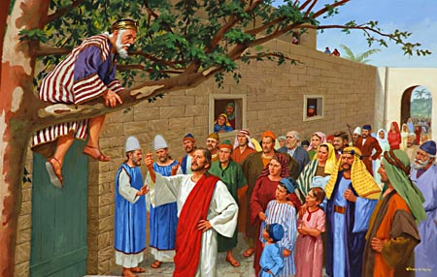

“Up In a Sycamore Tree”

First Presbyterian Church
21st Sunday After Pentecost
30 October 2022 - 10:30 A.M.

