
THE WORSHIP OF GOD

The Gathering

*Indicates congregation may stand.
Prelude

Welcome and Announcement Please sign & pass the fellowship pad.

Introit
Please use this contemplative time to prepare yourself to encounter God in this time and place.

“And we know that for those who love God all things work together for good, for those who are called according to His purpose.”
Romans 8:28

*God Calls Us to Worship

This is the day the Lord has made:
A day for praise and prayer; a day for gratitude and generosity.
This is the time God has given us:
A time for singing and silence; a time for speaking and listening.
This is the life to which God calls us:
A life of humility and service; a life of faith and trust.
*Hymn of Praise “Faith of Our Fathers” No.279

*Call to Reconciliation

When we pray to God, do we do so with pride in what wonderful people we are, or with that humble hope which recognizes how we have not lived as God’s children, and how we need God’s forgiveness and grace in our lives? Join me as we pray to our God, saying,

*Unison Prayer for Forgiveness

Watching God, like the Pharisee, we think we can stick our thumbs into life, pull out
a prayer, and congratulate ourselves for being such good Christians. Then, we
remember the harsh words we have spoken this week, the hurt we have inflicted on
someone we love, the lack of compassion we failed to offer to someone who needed our
help.
Forgive us, God of Grace, and deal gently with us. May we become more like the tax
collector - humble, penitent, acknowledging our faulty lives to you. Then, may we
receive the mercy promised to us through Jesus Christ, our Lord and Savior, Through
whom we pray, “Our Father… Amen.”

*Assurance of Pardon

*Prayer of Dedication

*Gloria Patri
Glory be to the Father, and to the Son, and to the Holy Ghost; As it was in the beginning, is now and ever shall be, world without end. Amen. Amen

*The Peace

The peace of God be with you.
And also with you.

Children’s Message
Please come forward during Passing of the Peace

Special Music “Deep, Deep Love” Jeff Griffith

THE WORD

Old Testament Reading Genesis 41:39-45

Expounding God’s Word “God is Always at Work”

The Response

*Hymn of Response “Faith Is the Victory” No. 486

*Bringing Our Gifts to God

*Doxology
Praise God, from whom all blessings flow; Praise *God all creatures here below;
Praise *God above, ye heavenly host; Praise Father, Son, and Holy Ghost. Amen.
(*or “Him”)

*Closing Hymn “Nothing But the Blood” No. 195

*Benediction

*Choral Closing “Ye Servants of God” No. 17

YE SERVANTS OF GOD YOUR MASTER PROCLAIM
AND PUBLISH ABROAD HIS WONDERFUL NAME;
THE NAMES ALL VICTORIOUS OF JESUS EXTOL;
HIS KINGDOM IS GLORIOUS, HE RULES OVER ALL.

Postlude
participating in the Service Today
Minister Rev. Daniel Winkowistch
Liturgist Kevin Sander
Organist Daryl Gommels
Worship Coordinator Beth Carrico
Sound Operator Walt Jensen
A/V Operator Lori Donovan/Beth Carrico
Chairlift Operator Larry Harsin
Radio Broadcast Sponsored by: Paul Moffitt and family in honor of all October birthdays

First Presbyterian Church
723 First Avenue South
Estherville, IA 51334
Phone: 712-362-4772 | E-mail: 1.church@mchsi.com
esthervillepresbyterian.com

Ordained Leaders and Elected Officers
Session –Kelly Claude, Molly Jo Anderson, Aaron Ruschy, Lori Donovan, Paul Moffitt, Walt Jensen, Kevin Sander, and Craig White.
Deacons –Janet Anderson, Cheryl Klingbeil, Evy Strenge, Georgia Whitehouse, Lavonne Ruschy, Kevin Strenge, John Klingbeil,
Mary Clabaugh and Pat Johnson.
PROGRAM STAFF - Darla Lundgren, Administrative Assistant, Daryl Gommels, Custodian

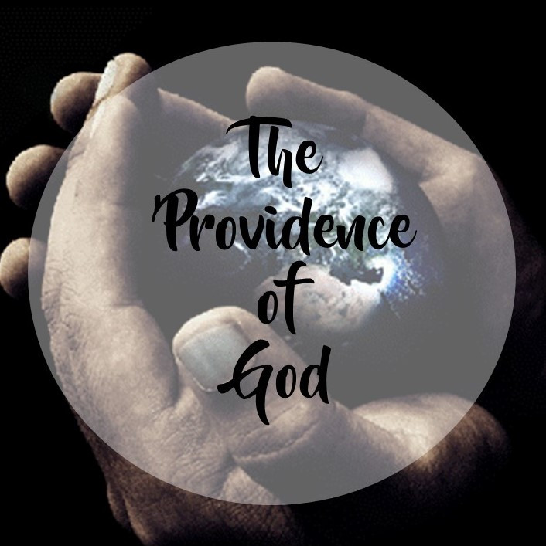

“God is Always at Work”

First Presbyterian Church
Reformation Sunday
20th Sunday After Pentecost
23 October 2022 - 10:30 A.M.

